# String Operations Activities

## Task 1

Write a program to generate 10 random numbers between 1 and 10 (inclusive), and print out the 10 numbers along with the total of the numbers. When run, the program should output something similar to:

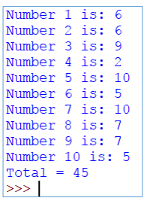

**Note:** Remember that you will need to import that appropriate module, in order to generate a random number.

## Task 2

Write a program to allow a user to enter a number of 5-character product codes, beginning with the letter “AB” or “AS” followed by 3 numeric characters.

Count and print the number of product codes starting with “AB” or “AS” and the total number of product codes ending in “00”. If the user types in a code beginning with “ac” or “as” it does not get counted.

The program should end when the user types in “xx”.

Test your program by entering product codes AS123m AS101, AB111, AB345, CD222, AB200.

When run, the program should output something similar to:

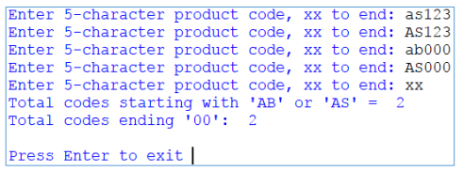

Expand your program so that when the user types in a code, the characters are stored in uppercase by default, for example, if the user types in “ab123” it would be treated the same as “AB123”. The program should run similar to:

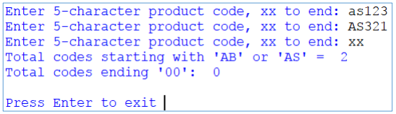

## Task 3

During the lecture we talked about the methods that the string class exposes. Write some code that shows your understanding of the following:

* isalpha()
* isdigit()
* isnumeric()
* find()
* split()
* string length
* iterating over a string

Read <https://pyformat.info> demonstrate the following:

* Positional format
* Named placeholders
* Number PI to 3 decimal places
* Both left and right aligned text

## Task 4

L33t sp33k. Convert some text to ‘leet’ speak. Convert at least 3 letters to numbers (E to 3, A to 4, L to 7)

## Task 5

Write a password checker. The user will enter a password, your code will check that it conforms to the following rules:

* More than 5 chars
* Less than 13 chars
* Has at least 1 capital letter
* Has at least 1 lower case letter
* Has at least 2 symbols in it
* Is not “password” (google the top 5 most common passwords and also check it is not one of those)

Hints: you *may* want to use a number of Boolean ‘flags’ (variables) that keep track of each rule the password passes.

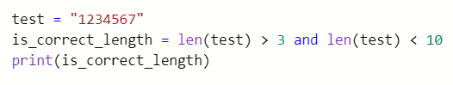

## Task 6

Create a flowchart of your solution to task 5

## Task 7

Write tests that test the code in task 5. Prove that the code works as per the specification.